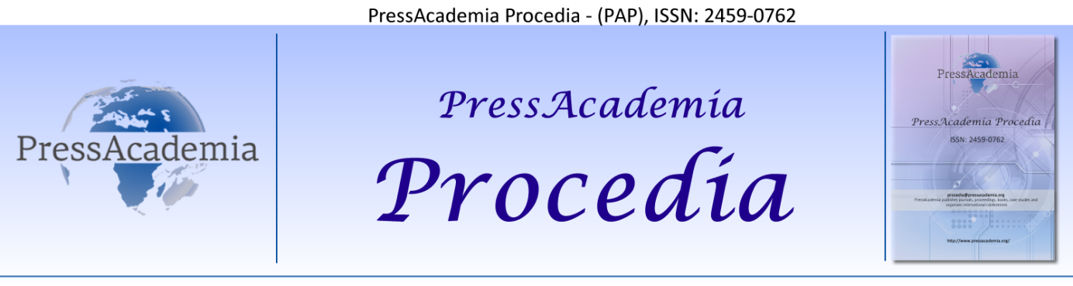
2nd World Conference on Technology, Innovation and Entrepreneurship,
May 12 - 14, 2017, Istanbul, Turkey.
Edited by Sefer Şener

TITLE of ARTICLE (12 punto, capital letters, bold, calibri, single space)
DOI: 10.17261/Pressacademia.2017….

Authors names (10 punto, lowercase letter, bold, calibri)
Author 1.Name of Institution (8 punto, calibri). Email (8 punto, calibri)
Author 2.Name of Institution (8 punto, calibri). Email (8 punto, calibri)
Author 3.Name of Institution (8 punto, calibri). Email (8 punto, calibri)

ABSTRACT
8 punto, calibri, single space, 150 words max)

Keywords: (5 keywords, 8 punto, calibri)
JEL Codes: (3 2-Digit JEL codes, 10 punto, calibri)

1. INTRODUCTION (TITLE – 12 punto capıtal letters, bold)
(10 punto, calibri, single space)

2. LITERATURE REVIEW
(10 punto, calibri, single space)

2.1. Xxxxxxxxx Xxxxxxx (Subtitles 12 punto, lowercase letters, bold)
(10 punto, calibri, single space)

2.1.1. Xxxxxxxxx Xxxxxxx (Subtitles 12 punto, lowercase letters, bold)
(10 punto, calibri, single space)

3. DATA AND METHODOLOGY
(10 punto, calibri, single space)

4. FINDINGS AND DISCUSSIONS
(10 punto, calibri, single space)

5. CONCLUSION
(10 punto, calibri, single space)

REFERENCES
(8 punto, calibri, single space)

